Week of March 21- March 28
- Finding launch window for Jupiter mission
  - Time taken to reach Jupiter
    - Running the simulation with probe of mass 17.7 kg tilted by 30° for 2 years, the probe reaches Jupiter’s orbit(~778,600,000 km from the Sun) at timestep 5160.
    - Total number of timesteps is 6311, so time taken is:
5160 / 6311 * 6.312*10⁷ = 51,608,176.20028 seconds
~ 597.316854 days ~ 19.63 months
  - Calculating arrival point angle
    - Starting coordinates of sail: 1.5e11, 0
    - Coordinates of sail when reaching Jupiter: -7.785e+11, 4.464e+10
    - Calculating angle of sail at arrival relative to the starting position:
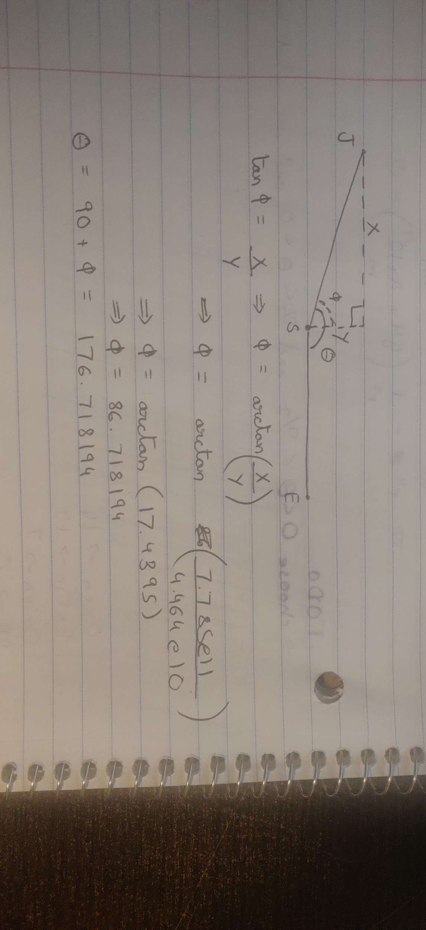
J and S are Jupiter and Sun, E is where Earth(and thus, the sail) will be at
launch.
X and Y are the coordinates where we need Jupiter to be when the sail
reaches it.
θ is the angle we are trying to calculate, ɸ is the angle between Jupiter and
the y-axis.
So, we need Jupiter to be at an angle of 176.718194° when our sail reaches it.
  - Calculating angle for launch
    - Using part 9 of the procedure here https://www.jpl.nasa.gov/edu/teach/activity/lets-go-to-mars-calculating-launch-windows/
    - Jupiter completes one orbit in 4,333 days, so the number of degrees it moves every day = (360/4333) = 0.083°/day
    - We know our sail takes 597.316854 days to reach Jupiter, so in that time the degrees that Jupiter will move = 0.083 * 597.316854 = 49.627°
    - We know that we need Jupiter to be at angle of 176.718194° at arrival, so the angle Jupiter should be relative to the Earth at launch:
176.718194° - 49.627° = 127.091194°
- Adding Jupiter to the simulation
  - Starting parameters
    - From Horizons, I first looked at ephemeris of the Earth to find the next date where it would be as close to our starting coordinates(1.5e11, 0) as possible. This date was 24 September 2022. I then replaced the coordinates and velocity of the sail with the ones from Horizon so our simulation can be as realistic as possible. The new starting parameters for the sail are:
      - X Position: 1.487339502126168 * 10¹¹ m
      - Y Position: 1.789363230737144 * 10⁹ m
      - X Velocity: -806.579104225 m/s
      - Y Velocity: 29,670.1076265 m/s
    - Starting parameters for Jupiter from Horizon, for the date 24 September 2022:
      - Mass: 1.898 * 10²⁷ kg
      - X Position: 7.386241849635403* 10¹¹ m
      - Y Position: 4.049731821142147 * 10¹⁰ m
      - X Velocity: -866.316490909 m/s
      - Y Velocity: 13,658.744864 m/s
  - Running the simulation
    - I ran the simulation with the sail and Jupiter for 12 years. I also changed the timestep to be 1 day, so that it is easier to compare our data with the Horizons data.
    - I plotted the path that Jupiter and the sail took. Below, the sail is depicted with purple and Jupiter is green:
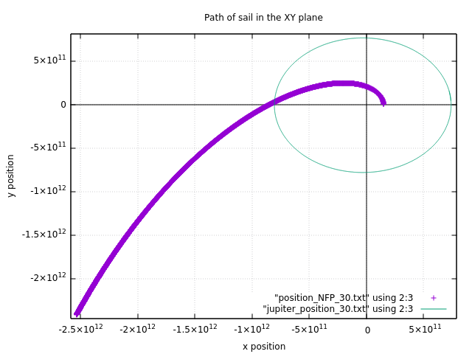
    - The simulation ran as expected, Jupiter went around the Sun and the sail sped away from it.
    - I also saved Jupiter’s position at every timestep to a file.
- Calculating Launch Windows
  - Getting Earth positions
    - I used an older version of the program without the solar sail and ran a simulation with just the Sun and the Earth for 12 years with a timestep of a day. I also saved the positions of the Earth at every timestep to a file. For Earth’s starting positions I used the Horizons data for 24 September 2022.
    - Now I have both Jupiter and Earth’s positions for the next 12 years, and I can use them to calculate the angle between Earth and Jupiter every day to find launch windows.
  - Writing a program to calculate angle
    - Theory
      - For each planet, if we have their X and Y position, we can calculate the angle relative to the Sun as follows:
θ_{planet} = arctan( Y/X )
      - Then, the angle between the planets will be:
θ = θ_{planet_1} - θ_{planet_2}
    - Program
      - The program first needs the angle that we are looking for in degrees, as well as the 2 files with positions of the planets. It also needs an accuracy parameter, which is basically how close the calculated angle can be to the target angle to be an acceptable launch window.
      - The program goes through the files and calculates the angle at each timestep like described in part i. above. Then, if the following condition is true, it prints out the timestep:
target_angle-accuracy ≤ calculated_angle ≤ target_angle+accuracy
    - Results
      - I used the positions files for Earth and Jupiter, the target angle I have calculated in part 1 to be 127.091194° and I set the accuracy to be 1.
      - The program found 14 timesteps, but half of them were consecutive so it really found 7 launch windows of 2 days each. The possible launch windows are below:
        - 1-2 June, 2023
        - 27-28 June 2024
        - 23-24 July 2025
        - 15-16 August 2026
        - 6-7 September 2027
        - 14-15 December 2032
        - 8-9 January 2034

