Week of March 28-April 4
- Compare Jupiter simulation orbit with Horizons
  - I made a graph to compare the orbit of Jupiter that our simulation calculated to the one estimated by NASA’s Horizon tool.
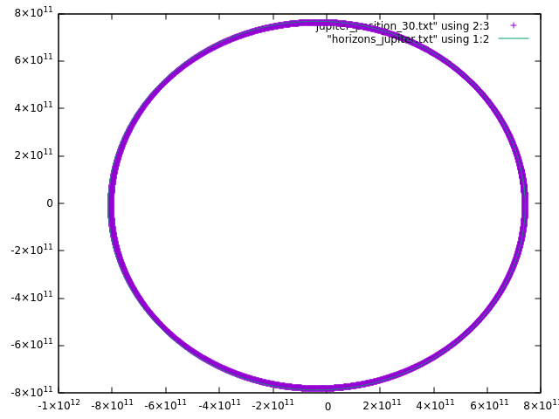
  - The orbits are close enough that they overlap on the graph. Seems like our simulation works well.
- Comparing synodic periods
  - Calculating synodic period
Period of Earth = 1 year
Period of Jupiter ~ 12 years
Synodic period = 1/(1-(1/12)) = 1/(11/12) = 1.0909 years = 398.18 days
  - Time between launch windows
The time between launch windows from the simulation:
    - 391 days
    - 390 days
    - 387 days
    - 386 days
    - 1,925 days
    - 389 days
  - Ignoring the one big outlier, which we investigate later, the launch windows found by our program seem to be roughly the same as the calculated synodic period, which is good.
- Investigating gap in launch windows
  - As we saw above there is a big gap in launch windows from September 2027 to December 2032. This doesn’t make sense since launch windows should occur at regular intervals of ~390 days as we saw above. There must be something wrong in the code then.
  - The large gap is between day 1809 and day 3734. The first launch window we would expect to see between them is at roughly day 2198. The angles around that day are as follows:
    - 2195 -234.50307485978857
    - 2196 -235.45730984516783
    - 2197 -236.41213933182473
    - 2198 -237.35949362364408
    - 2199 -238.32069016138428
    - 2200 -239.2642036105832
    - 2201 -240.22074079637625
All these angles are negative, while our target angle is 127.091194°.
  - With Dr Richmonds help, we figured out that at times, the angle between Earth and Jupiter might be (target angle) - 360° , which is also a valid angle for a launch day.
  - So, I added another check to the program to also check for a negative target angle, which would be equal to (target angle) - 360°.
- Investigating possible resupply missions for Jupiter
  - Recent ISS resupply mission payloads
    - I looked at the most recent resupply missions that NASA has sent to the ISS:
      - Cygnus NG-17 payload(Feb 2022):
        - Total: 3,651 kg
        - Crew supplies: 1,352 kg (2,981 lb)
        - Science investigations: 896 kg (1,975 lb)
        - Spacewalk equipment: 60 kg (130 lb)
        - Vehicle hardware: 1,308 kg (2,884 lb)
        - Computer resources: 35 kg (77 lb)
      - SpaceX CRS-24(Dec 2021):
        - Total: 2,989 kg
        - Crew supplies: 386 kg (851 lb)
        - Science investigations: 1,119 kg (2,467 lb)
        - Spacewalk equipment: 182 kg (401 lb)
        - Vehicle hardware: 328 kg (723 lb)
        - Computer resources: 33 kg (73 lb)
      - SpaceX CRS-23(Aug 2021):
        - Total: 2,207 kg
        - Science investigations: 1,046 kg (2,306 lb)
        - Vehicle hardware: 338 kg (745 lb)
        - Crew supplies: 480 kg (1,060 lb)
        - Spacewalk equipment: 69 kg (152 lb)
        - Russian hardware: 24 kg (53 lb)
    - “Crew supplies” looks like what we were thinking of sending for our resupply missions. I didn’t find anywhere that says what exactly that means, but I would imagine it includes things like food, water, clothing, Christmas gifts.
    - There are currently 7 people on the ISS. For our estimation, we’ll just divide by 7 to get an approximate number for 1 person. We get the following weights:
      - 193.14 kg (Cygnus)
      - 55.1 kg (SpaceX CR-24)
      - 68.57 kg (SpaceX CR-23)
    - All the data here is from https://en.wikipedia.org/wiki/Uncrewed_spaceflights_to_the_International_Space_Station#Current_and_completed_spaceflights, I only looked at recent NASA missions so we could easily compare.
    - From https://observer.com/2015/11/an-inside-look-at-how-nasa-resupplies-the-international-space-station/, the ISS apparently requires 33,000 lbs of supplies for a crew of 6 every year on average. That comes out to ~2,495 kg per person per year.
  - ISS resupply frequency
    - From the above link, we can see that the ISS gets resupplied every 2 months or so.
    - Chel Stromgren, who does logistics planning for NASA mentions that they never go 120 days without resupplying the ISS. (source: https://www.nasa.gov/johnson/HWHAP/packing-for-mars)
  - Can our solar sail do resupply missions for Jupiter?
    - I don’t think we should use the solar sail to resupply. If we resupply every year we will need to send hundreds of kgs at least, if not thousands that are estimated above. The solar sail depends on having very small payloads, so I don’t think it would be appropriate for a mission like this.

