Activity 3 Name _____________________

Change in the Universe

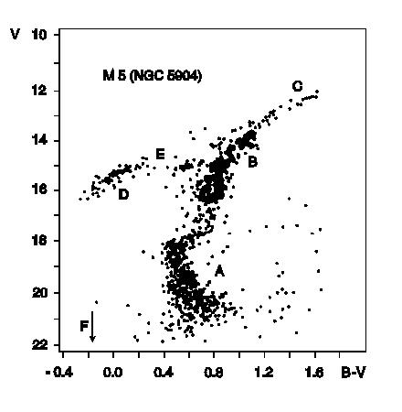

1. The diagram above is a color-magnitude diagram for a globular cluster. It was generated by measuring the brightness and color of the stars in a small piece of the cluster, and then plotting brighter stars at the top of the diagram and fainter stars towards the bottom. Bluer, hotter stars are plotted towards the left, and redder, cooler stars are plotted towards the right.

(a) Circle the stars which are generating their energy from nuclear reactions which convert hydrogen to helium, and label them “main sequence.”

(b) Clearly label the stars on the red giant branch.

(c) Which of the stars in this diagram are more massive – the stars on the red giant branch or the stars on the main sequence?

(d) Which of the stars in this diagram are older – the stars on the red giant branch or the stars on the main sequence?
(e) Which type of star is further away from us – the stars on the red giant branch or the stars on the main sequence?

(e) When this star cluster was younger, were the stars that are currently on the giant branch bluer, redder, or the same color that they are now?

(f) Clearly label the horizontal branch stars in this diagram.

(g) Clearly label the stars on this diagram which are probably not at the same distance as the globular cluster.

(h) Choose the best answer:
- These stars are farther away than the cluster.
- These stars are closer than the cluster.
- It is not possible to tell whether these stars are farther away or closer than the cluster.

Explain why you chose your answer:

2. Circle the items from the list below whose properties do evolve with time.

Stars Spiral galaxies Elliptical galaxies Star clusters

Galaxy clusters The Earth The Sun The Milky Way

Constellations

3. Give two reasons that the constellations we see in the sky today are different from the constellations two thousand years ago.

4. Describe your location in the Universe, as best you can.

5. Imagine you are a scientist and you are interested in how galaxies evolve. How do you think you could study this problem? There are many observational and theoretical ways this is being done today. See how many you can come up with.

