Activity 2 Name __________________

Discussions of the Contents of the Universe

Here are some things I think you already know:

(A) Some objects emit more light than other objects, and are therefore intrinsically brighter. If several objects (like light bulbs with different wattages) were placed at the same distance, then you could look at them and rank their brightnesses.

(B) If you move an object, like a light bulb, farther away from you, it looks dimmer. If you move it closer, it is brighter.

(C) If several objects have different brightnesses and different distances, it is difficult to tell which are brighter because they are closer and which are brighter because they are intrinsically brighter. To do this, you might want to estimate the relative distances of each object, or use some other information about the objects to guess which is intrinsically brighter.

(D) As metal is heated, the color changes. A very hot pot (900 K) turns red – red hot. If it is heated even more, to 1700 K, it turns yellow. Heated to 3000 K, it turns yellow-white. Over 5000 K, it turns bluish-white.

One thing astronomers have found by looking up in the sky is that there are not just randomly distributed stars everywhere. There are also clusters (groups) of stars in the sky. We look at each star in a cluster and estimate the color (we have a numerical way of doing this) and the brightness that we see (not the intrinsic brightness, since we do not know that – to know the intrinsic brightness we would also need to know the distance). The attached pages show plots of the star colors and brightnesses in a bunch of different star clusters. The horizontal axis is the color (bluer on the left and redder on the right). The vertical axis is the apparent brightness (brighter is up, dimmer is down).

Question 1: The size of a star cluster is small compared to the distance between us and the star cluster. How would these diagrams change if the stars were evenly distributed in space between us and the edge of the Galaxy?

Question 2: For each diagram, circle the hottest stars, and put a square around the brightest stars.

Question 3: Astronomers divide the clusters into two types, Galactic and globular. Do you see two types of clusters from the diagram? If so, what are their distinguishing characteristics?

Question 4: Astronomers identify features in the plots. Looking at the set of diagrams, what types of features do you think could be used to differentiate the star clusters, within the two classes above?

Question 5: What physical properties of the star clusters do you think cause differences between the plots? Remember – these plots do not show the positions of the stars in the sky.
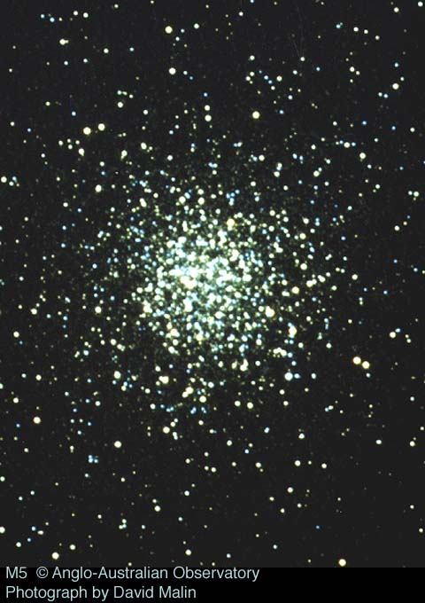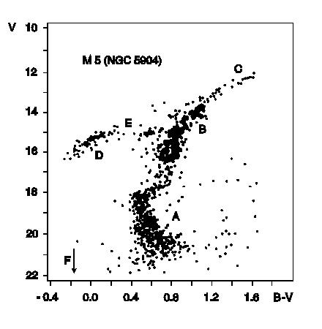
This is a picture of a star cluster taken with a telescope in Australia.
This is an H-R diagram. The properties of each star in the picture above were measured. The “B-V color,” which is a measure of the star’s temperature, was plotted on the X axis, and the “V magnitude,” a measure of how bright each star looks is plotted on the Y axis.

