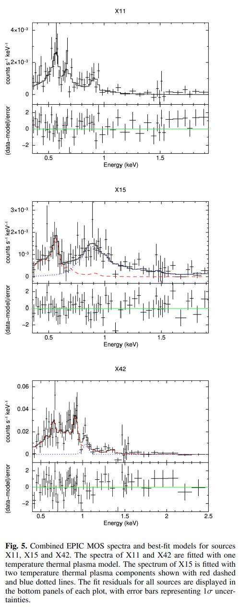
Class Problem – Astronomical Observation and Instrumentation
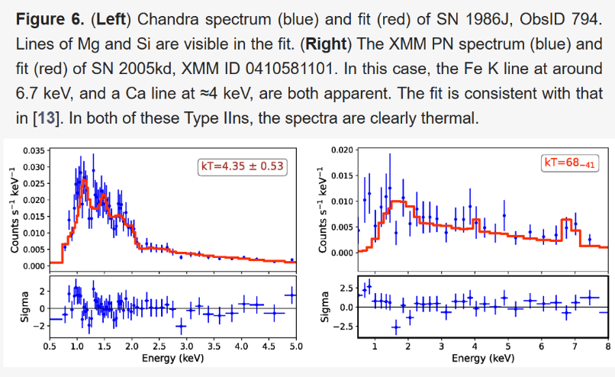

Sources: https://arxiv.org/pdf/2506.09120 and https://www.mdpi.com/2218-1997/11/5/161
- What portion of the EM spectrum is being studied in Figures 5 and 6 above? (might block out captions for this)
X-ray or 0.35-8.0 keV are acceptable
- Using the table, identify the elements seen in the three objects.
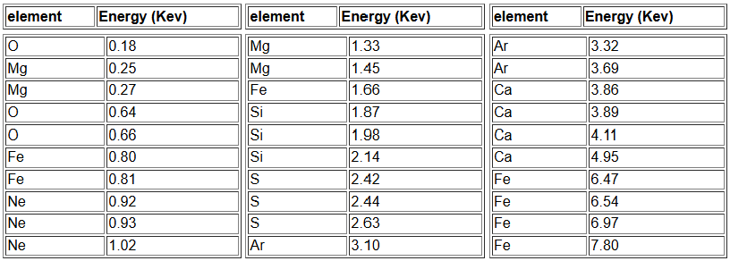
X11: 0.55-0.6 keV (O), 0.63-0.67 keV (O), 0.88-0.92 (Ne)
SN 1986J: ~1.2 keV (Mg), ~1.5 keV (Mg), 1.8-2.0 (Si)
SN 2005kd: ~1.7-1.8 keV (Fe or Si okay), 4.0 keV (Ca), ~6.7-6.9 keV (Fe)
- Based on these elements, what type of supernova did each of these remnants come from? Justify your answer.
X11: type Ib or II
SN 1986J: Type Ib or II
SN 2005kd: type Ia
- If the spectra of X11 is assumed to be completely thermal, what temperature would its source be?
Peak λ ~0.6 keV, $T=\frac{0.003 m⋅K}{λ_{peak}}=\frac{0.003 m⋅K}{hc/E}=\frac{0.003 m⋅K}{\left(\frac{1240 eV⋅nm}{600 eV}\right)⋅\frac{m}{{10}^{9} nm}}=1.45⋅{10}^{6} K$
Peak λ ~0.55 keV, $T=\frac{0.003 m⋅K}{λ_{peak}}=\frac{0.003 m⋅K}{hc/E}=\frac{0.003 m⋅K}{\left(\frac{1240 eV⋅nm}{550 eV}\right)⋅\frac{m}{{10}^{9} nm}}=1.33⋅{10}^{6} K$
Answer should be within this range
- If this same temperature is instead caused by shocks within the Sne remnant, what would be the material’s initial velocity if the material is stationary after the shock? (Assume a pure Hydrogen material, $m_{H}$ = 1.67 x 10⁻²⁷ kg and 1eV = 1.602 x 10⁻¹⁹ J)
0.6 keV, $E_{i}=ΔE→\frac{1}{2}m_{H}v_{i}^{2}=\left(600 eV*\frac{1.602⋅{10}^{-19} J}{1 eV}\right)$
$$→v_{i}=\sqrt{\frac{\left(600*1.602⋅{10}^{-19}\right)}{\frac{1}{2}m_{H}}}=3.39⋅{10}^{5} m/s$$
0.55 keV, $E_{i}=ΔE→\frac{1}{2}m_{H}v_{i}^{2}=\left(550 eV*\frac{1.602⋅{10}^{-19} J}{1 eV}\right)$
$$→v_{i}=\sqrt{\frac{\left(550*1.602⋅{10}^{-19}\right)}{\frac{1}{2}m_{H}}}=3.25⋅{10}^{5} m/s$$
Answer should be within this range
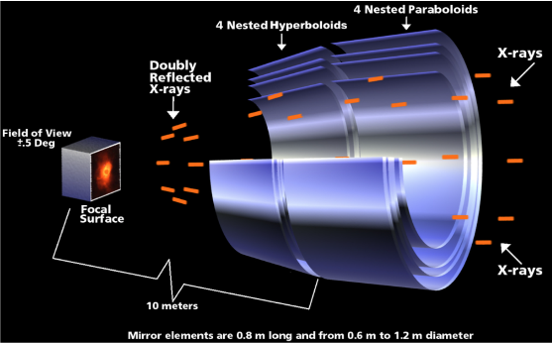
- Both sets of data were taken with Chandra, can you draw a rudimentary diagram of the telescope?

- Finally, if the detector collects a field of view +/- 0.5 deg but is the physical size of 16.9’ x 16.9’, what total deflection does Chandra’s most external mirrors (aperture of 1.2 m) need to apply to incoming light if the optical bench is 10 m?
60’ 16.9’

